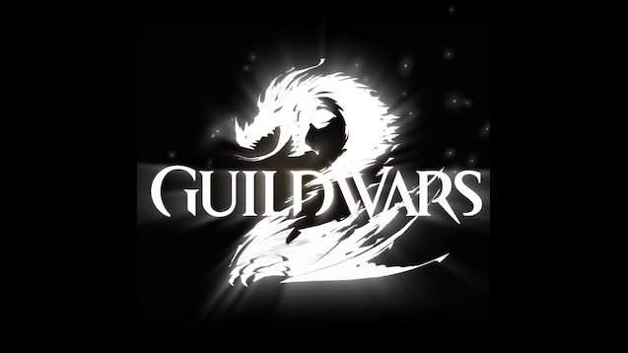

GUILDWARS 2 Guide Ancestral Tree Guide

Things you need to know about the Ancestral Tree meta & The Convergence of Sorrow II: Requiem achievement.

By Minerva Frostleaf AKAKenar Solmen

guardian of the united[gotu] & Exodus/z of the elder dragons/z [GODS]   EU based

The Ancestral Tree meta isn’t a meta for special rewards but aimed at telling a story related to the Elegy and Requiem armor sets. So the main purpose for this one is to unlock several steps of the 2nd Convergence of Sorrow Achievement.

**Prerequisites:**

1. Have access to the Jahai Bluffs
2. Have Sun’s Refuge unlocked (the story needs to be completed for this).
3. Have the achievement “Convergence of Sorrow I: Elegy completed. Otherwise it won’t unlock the 2nd achievement which requires this meta event. And this way we are sure that Amira (she is the armor smith) is in Sun’s Refuge.

Ancestral Tree Meta

The meta itself is a 30 minute cycle which starts at the xx:00 and xx:30 on a continuous cycle.

Every 10 minutes the cycles reset and the events change in the temporal dome. The first one requires the most timing, the 2nd and 3rd phase are all on the same location.

Phase 1[1]:

When this phase starts everyone moves into the dome and the event “Find the djinn vessel before the Brandstorm overwhelms the area” needs to be completed. For this 15 Weathered Vessels need to be checked inside the dome within 3 minutes.

After this the players will need to talk to several NPC’s in sequence (this needs to happen in the remaining 7 minutes of the first cycle):

1. Vemyen, the Djinn who appeared to save the group.
2. Meikka, she is standing next to the Djinn and is one of the NPC’s who was saved.
3. After this they go to Venta Pass Waypoint and enter Sun’s Refuge, go to the center and take the bridge to the right where Amirah is working (the smith from the first achievement). Talk to her and return to the Ancestral Tree
4. Talk to Meikka again to get the 5th unlock on the achievement.

Phase 2:

When the phase resets and the second phase starts everyone gets kicked out and you need to go back in the dome. This time the event to complete is: “Prevent Brand energy from overwhelming the area”.

For 3 minutes break all purple crystals spawning preventing the bar with the timer to be filled completely. After it completes talk to Noori who is standing next to the Ancestral Tree. Wait for the timer to run out again.

Phase 3:

This is a reset phase, so no events to perform. Just have the players talk to Noorima who is standing next to 4 graves along the mountain ledge (left hand side). This will unlock the 7th part of the achievement.

Side notes:

* As the interest for the Ancestral Tree meta is limited to those working on the Requiem collection there aren’t a lot of people looking for it on LFG. As such it’s a good idea to combine it with other events which will draw out more players.

The most logical one for this is to include the Death Branded Shatterer (as it is also required for the Requiem collection) and one of the other Path of Fire Meta events. For example Serpent’s Ire.

So a possible set is: xx:30 – xx:55 on the Ancestral Tree after which you start the escorts to the Death Branded Shatterer at xx:00. And after that switch to Serpent’s Ire at xx:30.

* The second side note is linked to the additional parts of the Reqiuem collection to advice players on. First of all they will need to kill a Branded Rift Stalker for the first step after the Ancestral Tree Meta. The one from the Legacy story instance will not give the Mist-Entangled item though, which is why the Death Branded Shatterer is a good combination as multiple of them will appear during the event guaranteeing a drop for everyone.

At this stage players will need to travel to the Durmand Priory, go into the instance left of the Hero Point and talk to Ely Scorchfire inside there (first room on the right in the priory, she is in the corner against the hallway so easy to miss). This will take them inside the library/collections part downstairs where she is in the storage space on the left hand side after crossing the big staircase. She will ask you to buy something from her which you can combine with the machine she is setting up and press a red button.

After this each Mist-Entangled item can be purchased from the NPC’s which have the hearts in the Jahai Bluffs. They need to be done in sequence and with every heart they complete they will need to visit Ely, buy additional stuff and follow the same routine.

For the final item they will need to kill the Death Branded Stalker again as this time it is on the dragon itself. Note that this should be the first time they kill it that day. If they’ve killed it before on that day it won’t drop the item and they will need to wait for the next day to get it.

1. For this phase it might be useful to have one person remain at the tree. Just to ensure everyone returns to the same instance so they end up with the completed event. This may not be necessary but is a precaution.